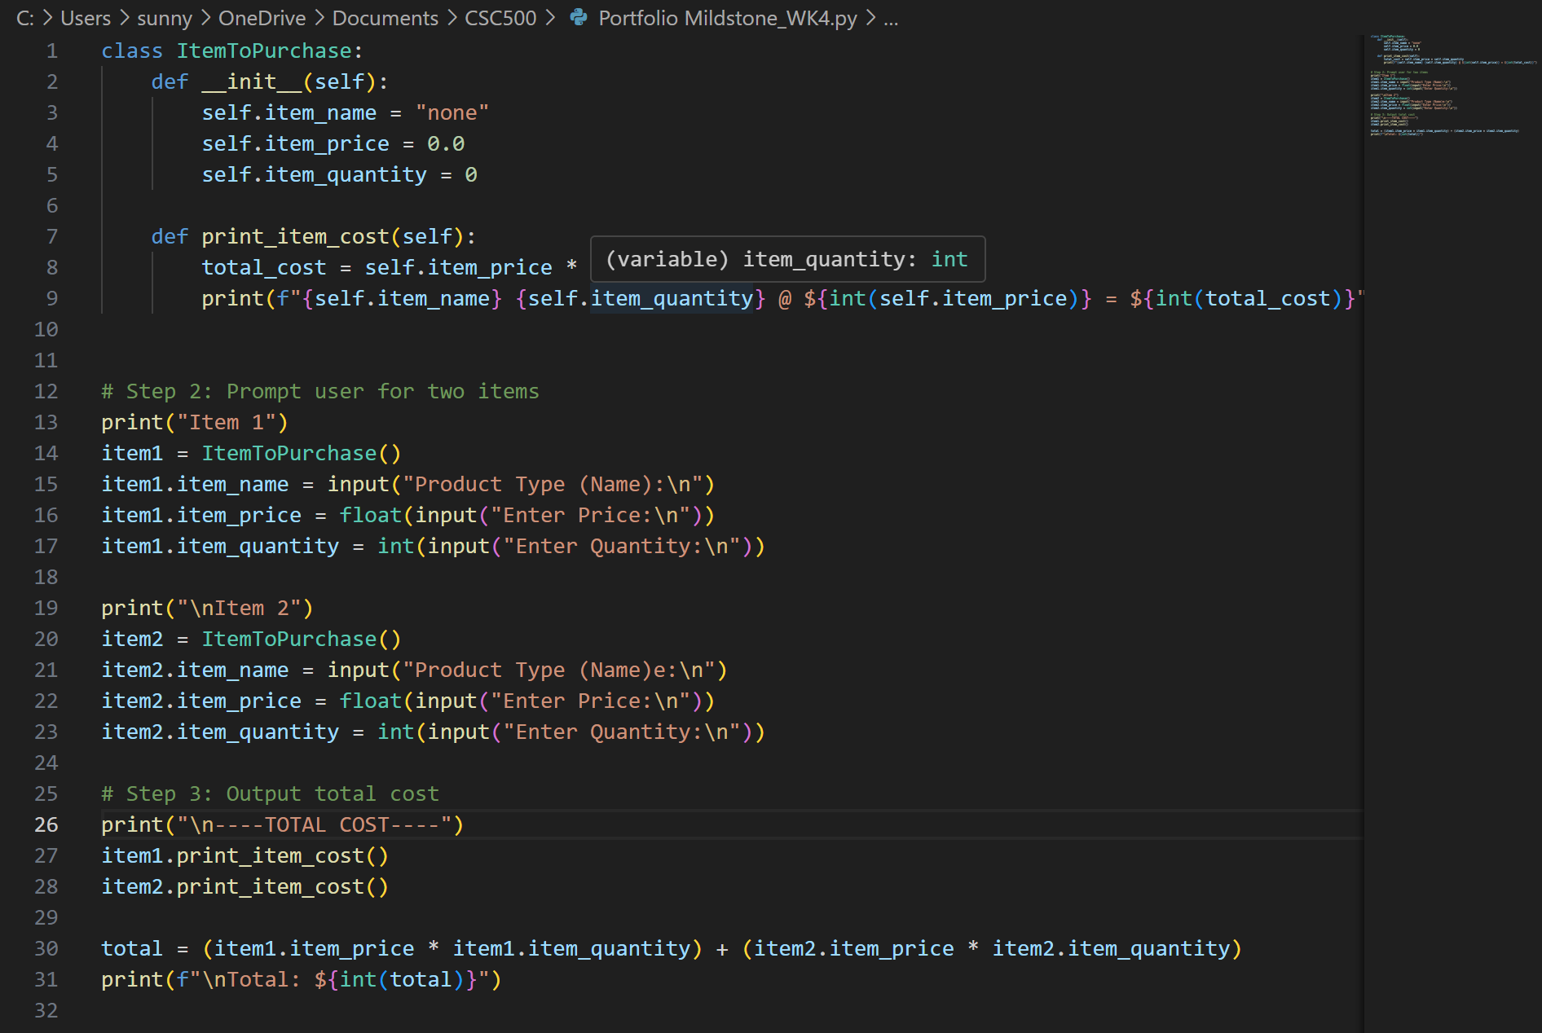
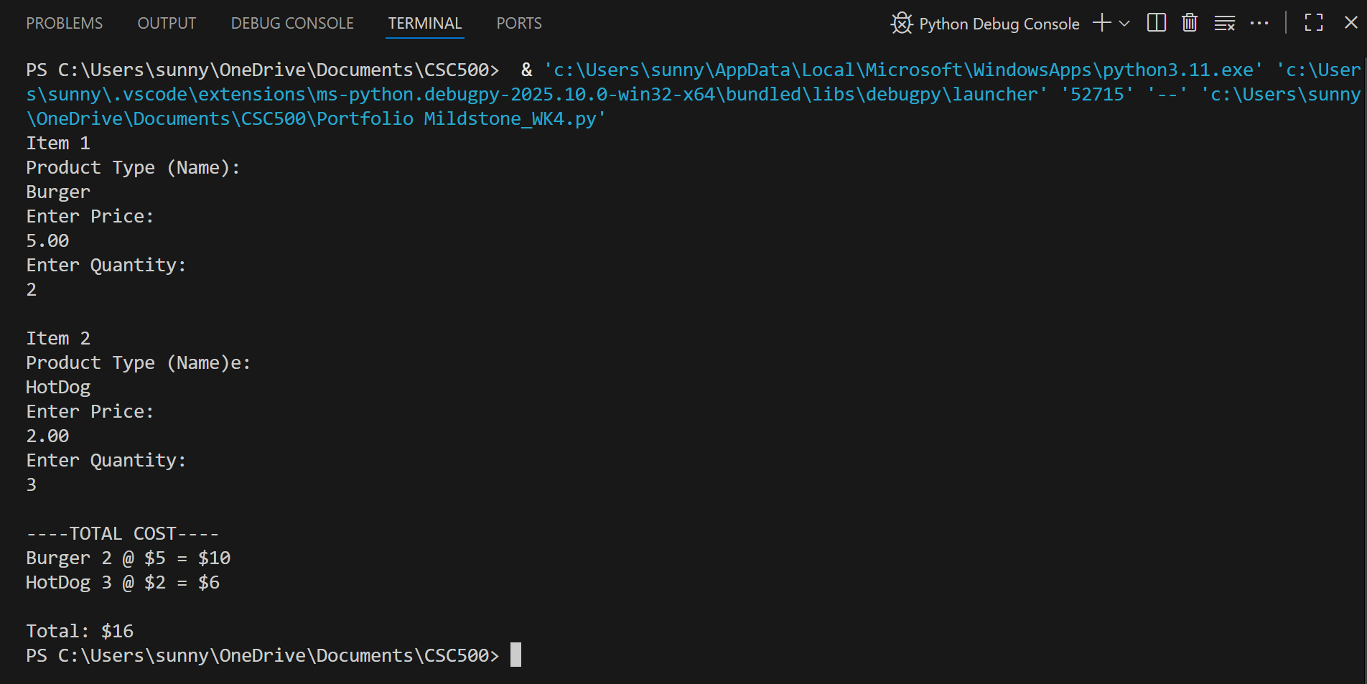
https://github.com/TiaHorton/CSC500/blob/549bfc59946928d282dc704acf7fff64b5b8446d/Portfolio%20Mildstone_WK4.py

